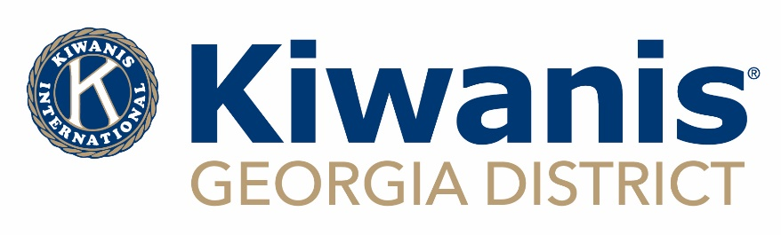
2018-19 Governor’s Cup Award
For Clubs and Lt. Governors

Revised 9/5/2018
CLUB: _____________________________________________________
 | CLUB | CRITERIA
MEMBERSHIP | Membership Growth | Club has net increase of at least one in membership  OR  Club sponsored or co-sponsored a new Kiwanis Club
 | Leadership Education  (REQUIRED at least 3 members attend in person class) | Club’s officers participated in 2018 Georgia Officer and Board Training (GOB). (President, Secretary, Treasurer, and 2 Board Members and/or membership chair. At least 3 members attend in person class)
 | Conference Attendance | Club represented by a member at all Division Council Meetings and the following:  Mid-Year Training, District Convention, or Kiwanis International Convention.
 | Interclub | Club completed an interclub visit with every club in their Division AND with one club outside of their Division (2 members from visiting Club counts as an official visit)
SERVING THE CHILDREN OF THE WORLD | Local Community Service | Club hosted projects or programs for children of the community.
 | Service Leadership  Program | Club sponsored a Service Leadership Program (SLP), BUGS Program, or Terrific Kids
 | Global  Community Service | Club contributed to Kiwanis International Children’s Fund and/or The Eliminate Project.
 | District Projects | Contribute recommended amount to all 5 Georgia District Sponsored Projects
ADMIN | Monthly Reports  (REQUIRED) | Monthly reports submitted within 30 days of previous month AND 2019-20 Election Report submitted by June 1, 2019
The club must have 7 stars out of 9 to Receive the Governor’s Cup.  Club will receive: Governor’s Cup Award and Certificate  SEE REVERSE SIDE FOR REST OF APPLICATION |  |  | Total Stars

LT. GOVERNOR: ____________________________________________
 | DIVISION | CRITERIA
DIVISION | Governor’s Cup Award Recipients | At least two-thirds of clubs in Division receive the 2018-19 Governor’s Cup Award.
 | Reports | Lt. Governor reports submitted by due date.
 | Council Meeting | Host at least three Division Council Meetings during the year. (physical or electronic)
The Lt. Governor must have ALL stars completed to Receive the Governor’s Cup.  Lt. Governor will receive: Governor’s Cup Award and Certificate |  |  | Total Stars

Club Name: ________________________________________________________________________________________

Club Key Number: ___________________________ Club Membership (Certified) on 10/10/18: ________________

Club President: ___________________________________________________ Phone: ___________________________

Email: _____________________________________________________________________________________________

Club Secretary: ___________________________________________________ Phone: ___________________________

Email: _____________________________________________________________________________________________

Division Lt. Governor: _____________________________________________________________ Division: __________

Please complete the form below and submit one copy to each of these BY OCTOBER 31, 2019:

- 2018-19 GEORGIA DISTRICT GOVERNOR – Debbie Brilling – dbrilling@avchears.org
- DIVISION LT. GOVERNOR
- GEORGIA DISTRICT KIWANIS OFFICE - Alexia Lieber - alexia@kiwanis.mgacoxmail.com

