2018-19 INTERCLUB POLICY
Interclub visits are fun and informative and can lead to lasting friendships. Kiwanis International is encouraging clubs close to newly Chartered Clubs to assist the new club to get them conducting business the “Kiwanis Way!” Some Divisions have some members join the new club and serve in leadership rolls the first year to make a smooth transition into Kiwanis International.
1. It only requires two members from a club to count as an “official” interclub visit.
2. Clubs will receive a banner patch IF they complete a interclub visit with every club in their Division AND one club out of your Division. (SLPs, Training conferences, and Conventions don’t count)
3. Patches will also be given to the top 10% of clubs who have the most visits, or the highest miles traveled at the end of the Kiwanis year. (Sept 30, 2019)
4. The first Club to report to me that they have completed task #1 will receive a $75 award. You MUST notify me in addition to entering the visits on the Secretary dashboard.

For More Information, Contact:
Byron Mullican, sgtmop@yahoo.com, (717) 552-1999

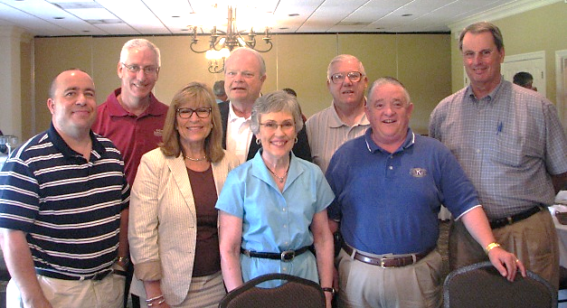

NOW, let’s get out there, grab a member, and GO Interclubbing!

