2021-22 INTERCLUB POLICY
Interclub visits are fun and informative and can lead to lasting friendships. They also give you an opportunity to see what other clubs are doing and allows you to adopt those activities that can be used in your club. In addition, Kiwanis International is encouraging clubs close to newly Chartered Clubs to assist the new club to get them conducting business the “Kiwanis Way!” Some Divisions have some members join the new club and serve in leadership rolls the first year to make a smooth transition into Kiwanis International.
- It only requires one member from a club to count as an “official” interclub visit.
2. Clubs will receive a banner patch IF they complete the interclub challenge. One of the challenges with interclub’s is the size of the Divisions in the Georgia District. The average size of a Division is eight clubs, with a range of four to thirteen clubs. In an effort to level the playing field as far as interclubs are concerned, to complete the interclub challenge a club must make a minimum of eight interclub visits. Seven of these visits must be with clubs in their Division AND one club out of your Division. The seven visits must be to separate clubs. In a small division, multiple visits to a club will count as long as you visit every club within your division. SLPs, Training conferences, and Conventions do not count for the interclub patch.
3. Patches will also be given to the top 10 clubs who have the most visits and to the top 10 clubs who have the highest miles traveled at the end of the Kiwanis year (Sept 30, 2022). SLPs, Training conferences, and Conventions do count for the Top 10 interclub patches.
4. Remember to report all interclubs on your monthly report and to me to assure you have credit for completing the challenge. You MUST notify me in addition to entering the visits on the Secretary dashboard.
For More Information, Contact:
Tim Goodman, goodman@ega.edu (478) 494-4741

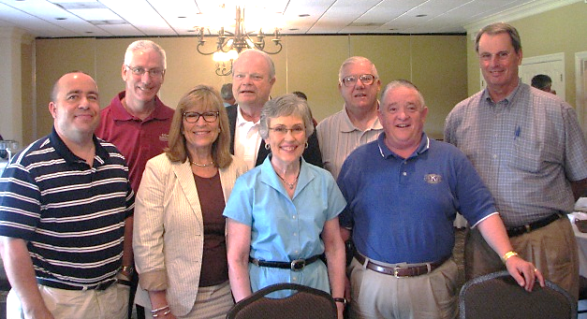

NOW, let’s get out there, grab a member, and GO Interclubbing!

