Georgia District of Kiwanis
2024
Art & Music Showcase
Handbook

Sponsored by the
Georgia District Kiwanis Foundation

Hosted by
Division 9 of the Georgia District of Kiwanis

April 27, 2024

Deadline for Applications is April 15, 2024

WELCOME TO MACON

MUSIC CAPITAL OF THE SOUTH

Home of Southern Rock & Roll & Georgia Sports Hall of Fame

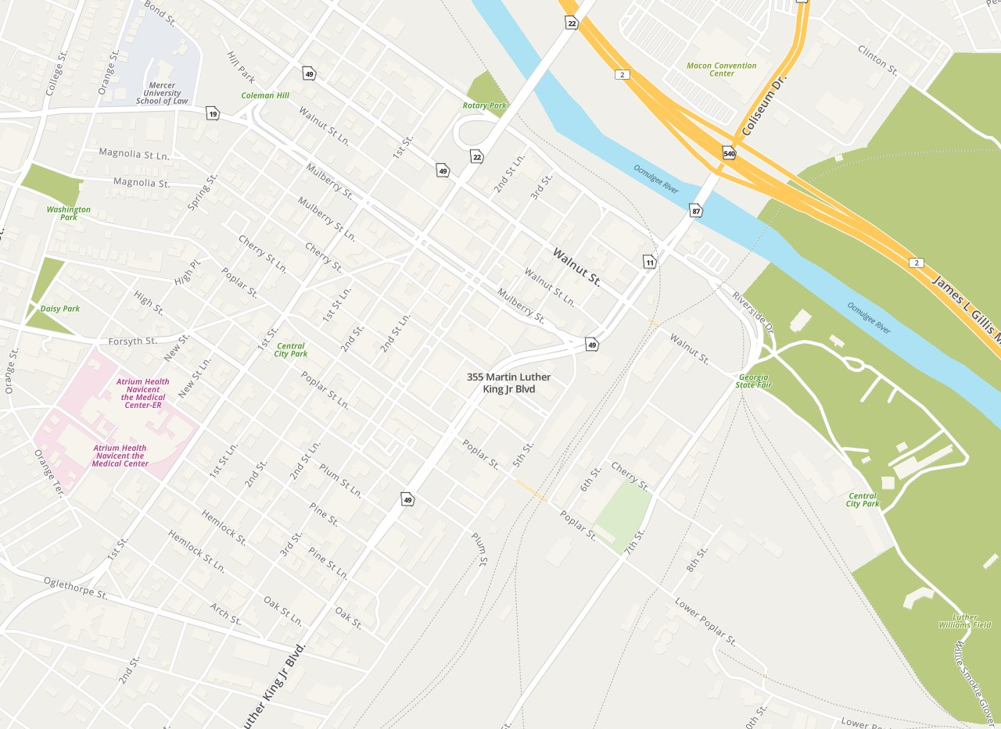
Douglas Theatre located a 355 MLK Blvd, with free parking next door

Introduction

For over 40 years the Georgia District of Kiwanis Art and Music Showcase has provided students with the opportunity to demonstrate their talents in a competitive atmosphere with students from across the state. The students have received certificates, trophies, awards, and scholarships in recognition of their talent and efforts.

In order to qualify for the District competition, the student(s) must:

- Be the winner of and be sponsored by a Kiwanis Club within Georgia that has conducted a local showcase during the same Kiwanis year.
- Meet the qualifications for the local and District competitions.

In 2023, the Georgia District Kiwanis Foundation provided a total of $15,000 in Educational Scholarships - $7,500 in the Art Contest and $7,500 in the Music Contest. The first-place award in each contest received an educational scholarship in the amount of $3,500.

Responsibilities of Club Committee Chair

- Coordinate Club activities with chairs of Sponsored Youth, Youth Services and Partnership Committees to solicit contestants for your local Art and/or Music Contest.

- Promote sale of sponsorships in the District Showcase program to cover cost of awards and other expenses. Sponsorships range from $50 to $250 and are defined on the Sponsorship Form in this Handbook.

- Review applications to ensure all information is correct and evaluate with contestants to determine appropriateness of item/act being submitted. Application must be signed by contestant, the contestant’s parent or guardian, and the local Kiwanis Club representative.

- All applications must be signed and validated by Sponsoring Club Committee Chair.

- Forward applications with appropriate fees to District Committee Chair.
- Fees for art competition are $15.00 per item with only one item to be submitted per contestant.
- Fees for music competition are $25.00 per act. No more than five individuals (including accompanist) will be permitted in an act.

- Applications received without fees and executed releases will not be accepted.

- All applications must be received by the District Chair on or before Friday, April 12, 2024.

- Contestants for the music competition will be selected on a first come, first selected basis, as only the first 24 acts can be selected. Club Chair must confirm that music entrants will be available to compete on April 27 in Macon GA.

- Ensure that Art items are at the appropriate location and time for the judging at the Georgia District Contest on April 27, 2024.

- Ensure that participants are present for the Georgia District Art and Music Showcase Competition at the appropriate time and place on April 27, 2024.

- Please communicate the rules that apply to music performances and art work.

- See Showcase Schedule for times.
The Art Competition - General Rules for Contestants

- All contestants must be sponsored by a Kiwanis Club in the Georgia District of Kiwanis International.
- Only one contestant per art submission is permitted. No group projects are permitted.
- All contestants must be students in good standing with their respective schools and currently registered in Grades 6-12.
- Contestants can only participate in one local Kiwanis sponsored "Art Showcase" (or competition path) within a school year.
- Art can be submitted in any of the following media: painting, drawing, printmaking, photography, ceramics, sculpture, metal work, graphic design, mixed media and crafts. Only one art item may be submitted per contestant. This item must be the same item for all levels of competition.
- All video media entries can be any length, but only the first 4 minutes will be judged.
- Art entries must be delivered to the competition by the participant or a club representative from 9 am to 11:00 am on the day of the competition. Commercial deliveries will not be accepted.
- Any art deemed unsuitable or objectionable by the committee will be excluded from the competition.
- Each art entry shall be the original work of the contestant submitting the item and may not be copied from a photograph. (A painting copied from a photograph is permissible only if the contestant is the photographer). An exception will be made for mixed media collage.
- An entry fee is required from the sponsoring Kiwanis Club in the amount of $15.00 per entry to defray the cost of hosting the competition. The check should be made payable to the Georgia District Kiwanis Art & Music Showcase and submitted with the entry application to: Georgia District Art & Music Showcase, c/o Showcase Chairman, Kiwanis Club of Macon, 182 Carriage Way, Macon, Ga 31210
- All applications and fees must be received by Friday, April 15, 2024.
- Judging will be done by grade. The top winner from each grade (6-12) in the local contest may be submitted for the District Competition. The artwork submitted must be the same artwork which won the local competition. One additional (overall) winner may be selected from Grades 9-12 for the District Competition, making a total of eight entries for the District Competition from the local contest.
- The art items must remain on display until the winners are announced at the end of the Music Showcase. Please ensure there is nothing which identifies the artist on the front of the artwork or frame, with the exception of the artist’s signature, which is permissible.

Note: To expedite entry application, we request that all framed artwork have a wire hanger.

ART – ART – ART - ART

Georgia District of Kiwanis
Art & Music Showcase
April 27, 2024

Application for Art Competition
Print all information legibly; mail one copy and attach one copy to back of artwork

Contestant Grade Phone

Medium Title

Address

School Parent’s Email

Method recommended for displaying Art (check one):
Pedestal Mounted Wall Hung Easel

Winner of local Showcase sponsored by Kiwanis Club of Division #
***********************************************************

Contestant and parent or guardian must complete this section

We, the undersigned Contestant and parent or guardian of the contestant, agree to abide by any and all decisions, regulations, and/or rules made by the “Kiwanis Art & Music Showcase” committee.

Contestant Signature Date Parent or guardian Signature Date

Parent/guardian email address Phone
Please print legibly

As club chairperson, I certify that the information above is correct and complete to the best of my knowledge. Names are spelled correctly and all information is legible for the Showcase program.

Printed name Chairperson’s signature

Date Email address Phone

Mail one copy of this form and attach one copy to back of artwork

ART – ART – ART - ART
Affirmation, Reliability and Photo Release Form

I, __________________________________, hereby affirm that I have been well advised and thoroughly informed of the inherent hazards and policies of the event. I know that participating in the Georgia District Kiwanis Art and Music Showcase is a potentially hazardous activity. I should not participate unless I am medically able. I hereby personally assume all risks associated with my voluntary participation in this event for any harm, injury or damage that may befall me as a result of my participation, whether foreseen or unforeseen, including but not limited to falling or injury on or off stage.

I understand and agree that neither Kiwanis International nor the Kiwanis Club of Macon located in the city of Macon and state of Georgia USA may be held liable in any way for any occurrence in connection with my participation in Georgia District Kiwanis Art & Music Showcase that may result in injury, death, or other damages to me or my family, heirs, or assigns, and in consideration of being allowed to participate in this event. I hereby personally assume all risks in connection with said event for any harm, injury or damage that may befall me, including all risks connected therewith, whether foreseen or unforeseen; and further to save and hold harmless said event and persons from any claim by me, or my family, estate, heirs, or assigns arising out of my participation in this event.

I further state that I am of lawful age and legally competent to sign this affirmation and release, or that I have acquired the written consent of my parents or guardians; that I understand the terms herein are contractual and not a mere recital; and that I have signed this document of my own free will.

It is my intention by this instrument to exempt and release Kiwanis International, the Ga District of Kiwanis and the Kiwanis Club of Lee County from all liability whatsoever for personal injury, property damage or wrongful death arising out of or in the course of my participation in this event.

I HAVE FULLY INFORMED MYSELF OF THE CONTENTS OF THIS AFFIRMATION AND RELEASE BY READING IT BEFORE I SIGNED IT.

For and in consideration of my participation with a Kiwanis sponsored event where photos were taken The 2024 Georgia District Art & Music Showcase, I hereby give Kiwanis, its employees, and those acting with its authorization, the right and permission to copyright, use, and/or publish photographic pictures or portraits of me in catalog, magazine, literature, web and direct mail promotion.

I hereby waive any right to inspect or approve the finished photograph, advertising copy or printed matter that may be used in conjunction therewith or to the eventual use that might be applied.

I hereby release, discharge and agree to hold harmless Kiwanis, its employees or vendors (including any firm publishing and/or distributing the finished product) from and against any liability as a result of any distortion, blurring or alteration that may occur in the taking, processing or reproduction of the finished product, even should the same subject me to ridicule, scandal or indignity.

I hereby warrant that I am competent to contract in my own name in so far as the above is concerned. I have read the foregoing release, authorization, and agreement before affixing my signature below, and warrant that I fully understand the contents thereof.

Printed name Signature

Address

City State Zip

Phone Date

Signature of Parent if under 18 years of age: Date:

Club Chairman Date

The Music Competition - General Rules for Contestants

- All contestants must be sponsored by a Kiwanis Club in the Georgia District of Kiwanis.
- All contestants must be students in good standing with their respective schools and currently registered in Grades 9-12.
- Contestants can only participate in one local Kiwanis "Music Showcase" (or competition path) within a school year.
- The act is limited to a vocal and/or instrumental performance.
- Contestant may participate in only one act. This act must be the same for all levels of competition. Any act deemed unsuitable or objectionable by the committee will be excluded from the competition.
- Groups of five (5) or fewer members including the accompanist may participate as an act.
- Except for the accompanist of an act, only amateur talent may participate in the competition. An amateur is one who has not signed a contract to receive payment or valuable compensation for performing the talent being submitted. If this status is in question, the District Committee shall make a ruling in the case.
- An entry fee is required from the sponsoring Kiwanis Club in the amount of $25.00 per act to defray the cost of hosting the competition. The check should be made payable to the Georgia District Kiwanis Art & Music Showcase and submitted with the entry application to: Georgia District Art & Music Showcase, c/o Showcase Chairman, 182 Carriage Way, Macon, Ga 31210. All applications and fees must be received on or before Friday April 15, 2024.
- Only one winner of the local showcase is eligible to compete at the District level.
- No act shall exceed four (4) minutes in performance time. All acts that exceed this time limit shall be disqualified. This rule will be strictly enforced.
- Scoring by the judges’ uses the following criteria:
    - Musicianship: 40 Points – Includes ability, difficulty, confidence and execution.
    - Artistry: 30 Points – Includes variety, challenge, and creativity.
    - Presentation: 30 Points – Includes poise, intensity, and professionalism.
    - Judges will also take into account the length of the performance and any other factors they feel are relevant.
- There will be 5 judges, each of whom controls 100 points. Should there be a tie the highest and lowest scores will be dropped and scores re-tabulated.
- A maximum of 24 acts will be accepted on a first-come, first-accepted basis. Applications will not be accepted without all documentation and fees.
- Background soundtracks that are used for vocal performances shall be instrumental only. No vocal backgrounds will be permitted for soundtracks that are used in vocal performances. Please have music ready to play in a digital format.

MUSIC – MUSIC – MUSIC

Georgia District of Kiwanis
Art & Music Showcase
April 27, 2024

Application for Music Competition
Please print legibly

Contestant Age

School Grade

Address

Phone Parent’s Email

If group, list names and attach an application for each member:

Type of talent Title (if any)

Composer Accompanist (if any)
Special equipment (if any) to be brought by contestants(s)
(Showcase will provide piano and stand mics only.)

Winner of local Showcase sponsored by Kiwanis Club of Division
**********************************************************
Contestant and parent or guardian must complete this section

We, the undersigned Contestant and parent or guardian of the contestant, agree to abide by any and all decisions, regulations, and/or rules made by the “Kiwanis Art & Music Showcase” committee.

Contestant Date Parent or guardian

Parent/guardian email address Parent/guardian phone
Please Print Legibly
As club chairperson, I certify that the information above is correct and complete to the best of my knowledge. Names are spelled correctly and all information is legible for the Showcase program.

Printed name Chairperson’s signature

Date Email address Phone

MUSIC – MUSIC – MUSIC

Affirmation, Reliability and Photo Release Form

I, __________________________________, hereby affirm that I have been well advised and thoroughly informed of the inherent hazards and policies of the event. I know that participating in the Georgia District Kiwanis Art and Music Showcase is a potentially hazardous activity. I should not participate unless I am medically able. I hereby personally assume all risks associated with my voluntary participation in this event for any harm, injury or damage that may befall me as a result of my participation, whether foreseen or unforeseen, including but not limited to falling or injury on or off stage.

I understand and agree that neither Kiwanis International nor the Kiwanis Club of Macon located in the city of Macon and state of Georgia USA may be held liable in any way for any occurrence in connection with my participation in Georgia District Kiwanis Art & Music Showcase that may result in injury, death, or other damages to me or my family, heirs, or assigns, and in consideration of being allowed to participate in this event, I hereby personally assume all risks in connection with said event for any harm, injury or damage that may befall me, including all risks connected therewith, whether foreseen or unforeseen; and further to save and hold harmless said event and persons from any claim by me, or my family, estate, heirs, or assigns arising out of my participation in this event.

I further state that I am of lawful age and legally competent to sign this affirmation and release, or that I have acquired the written consent of my parents or guardians; that I understand the terms herein are contractual and not a mere recital; and that I have signed this document of my own free will.

It is my intention by this instrument to exempt and release Kiwanis International, the Ga District of Kiwanis and the Kiwanis Club of Lee County from all liability whatsoever for personal injury, property damage or wrongful death arising out of or in the course of my participation in this event.

I HAVE FULLY INFORMED MYSELF OF THE CONTENTS OF THIS AFFIRMATION AND RELEASE BY READING IT BEFORE I SIGNED IT.

For and in consideration of my participation with a Kiwanis sponsored event where photos were taken The 2024 Georgia District Art & Music Showcase, I hereby give Kiwanis, its employees, and those acting with its authorization, the right and permission to copyright, use, and/or publish photographic pictures or portraits of me in catalog, magazine, literature, web and direct mail promotion.

I hereby waive any right to inspect or approve the finished photograph, advertising copy or printed matter that may be used in conjunction therewith or to the eventual use that might be applied.

I hereby release, discharge and agree to hold harmless Kiwanis, its employees or vendors (including any firm publishing and/or distributing the finished product) from and against any liability as a result of any distortion, blurring or alteration that may occur in the taking, processing or reproduction of the finished product, even should the same subject me to ridicule, scandal or indignity.

I hereby warrant that I am competent to contract in my own name in so far as the above is concerned. I have read the foregoing release, authorization, and agreement before affixing my signature below, and warrant that I fully understand the contents thereof.

Printed name Signature

Address

City State Zip

Phone Date

Signature of Parent if under 18 years of age: Date:

Club Chairman Date
Georgia District of Kiwanis
Art & Music Showcase
Showcase Schedule

April 27,2024
Saturday

ART COMPETITION
DOUGLAS THEATER
MACON, GA

9:00 am – 11:00 am Setup

11:00 am Deadline for Art Entries
11:30 – 1:30 pm Judging

1:30 – 3:00 pm Public Viewing/Artists’ Reception

Art & Music Showcase Awards Ceremony following the Music Showcase

MUSIC COMPETITION
DOUGLAS THEATER
MACON, GA

10:00 am - 2:00 pm Dress Rehearsal
Dress Rehearsal will be scheduled by Music Chair, based upon contestant’s distance from Macon Ga.

3:00 pm Performance and Judging

Art & Music Showcase Awards Ceremony following the Music Showcase

Deadline for Applications and Sponsorships is April 27, 2024

Georgia District Kiwanis Art & Music Showcase
Steering Committee

John W Davis, Showcase Chair
3200 Riverside Dr #250
Macon, GA 31210 Phone: 478 714-2866
Email: jdaviscltc@yahoo.com
Kiwanis Club Macon

John Davis Chair – Music Showcase  Kiwanis Club of Macon | Craig Ellard Chair- Art Showcase  Kiwanis Club of Macon
Hazel Struby, President
Kiwanis Club of Macon

Jim Tessmer-Secretary
Kiwanis Club of Macon

Georgia District Kiwanis 2024 Art & Music Showcase
Sponsor Commitment

I support the Georgia District Kiwanis and pledge to sponsor the Art & Music Showcase.

Please fill out the sponsor information below and deliver to a Kiwanis Club of Lee County or mail to:
Kiwanis Club of Macon
Attn: Showcase Chairman
182 Carriage Way, Macon GA 31210

Return completed form with check by April 12, 2024

Please Make Check Payable to: Georgia District of Kiwanis Art & Music Showcase

Name of business/sponsor/club

Name Title

Address

________
Email

Sponsors who contribute $100 or more (Awards or Major Sponsor Level) will receive a free video of the Showcase performance (includes music and art winners).
Sponsorship Level | Cost | Amount
Major Level Sponsor | $250 or more | $
Awards Level Sponsor | $100 - $249 | $
Supporter Level Sponsor | $50 - $99 | $
Contestant Fee | $25 music/$15art (per entry) | $
Grand Total |  | $

The Georgia District Kiwanis Foundation
And
Division 5 of the Georgia District of Kiwanis

Cordially invite you to

The Georgia District of Kiwanis

2024 Art & Music showcase

ARTISTS’ RECEPTION

Saturday, April 27, 2024

1:30 – 3:00 pm

Douglas Theater
355 MLK Blvd
Macon GA 31210

