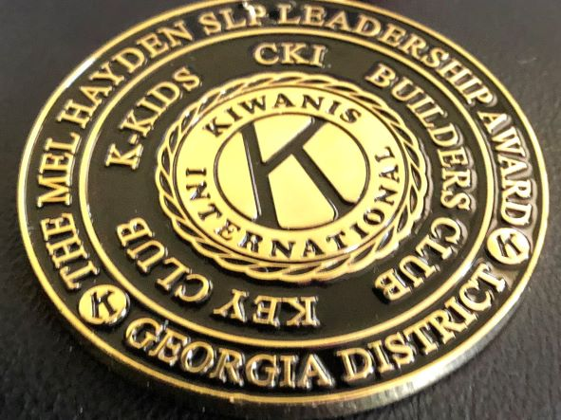

The Governor of the Georgia District of Kiwanis
is honored to present the
THE HAYDEN STUDENT LEADERSHIP MEDALLION

To

for
Outstanding Service Leadership in the ________ Club Student Leadership Program

GOVERNOR, GEORGIA KIWANIS DISTRICT DATE

