Press Release for Georgia Kiwanis
What: Kiwanis Read Across Georgia Day
When: January 21, 2022
Where: At a local elementary, Pre-K, or Head Start center in your community

Why: To promote reading and to try to help children read on grade level before they finish the 3rd grade. If a student isn’t on grade-level in reading by the 3rd grade, probability is high for a student not to graduate from high school. We will be celebrating Kiwanis’ 107th anniversary as well.

THE KIWANIS MISSION
Kiwanis empowers communities to improve the world by making lasting differences in the lives of children.
​
THE KIWANIS VISION
​Kiwanis will be a positive influence in communities worldwide — so that one day, all children will wake up in communities that believe in them, nurture them and provide the support they need to thrive.

Contact: Dr. Rick Townsend, 912-506-5347 or for additional information or you can contact your local Kiwanis club. I can help you reach out to them as well.
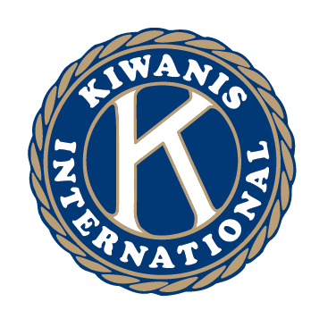 | Kiwanis International is a global organization of volunteers dedicated to improving the world one child and one community at a time.  Kiwanis helps kids around the world. Local clubs look out for our communities, and the international organization takes on large-scale challenges, such as disease and poverty. We are generous with our time. We are creative with our ideas. We are passionate about making a difference. And we have fun along the way.
With our network of over 600,000 members in Kiwanis and our Service Leadership Programs, we can truly change the world. We believe that Kids Need Kiwanis, so we serve children in any way we can, from food insecurity to improving literacy to raising money.

